# Introduction

In this section we built a packet tracer network diagram to illustrate how the Webserver that the block-gain website and the user database are stored.

The Network consists of two main ISPs (Internet service providers) that the Border Router is connected through two serial links, one primary and secondary links with BGP protocol.

The border router is also connected to the local router with one serial link with OSPF protocol. The BR router redistributes between BGP and OSPF.

The local router is connected to the access layer via g0/0 in trunk mode dotq encapsulation which translates between Vlan 10 web server Vlan and Vlan 99 management Vlan.

Apart from the necessary configuration there are few access lists in place. Access-list 10 which only allow that management PC can access the routers and the Switches via SSH.

Access-list 101 which only allows http traffic from the ISP to the webserver.

Packet Tracer Diagram

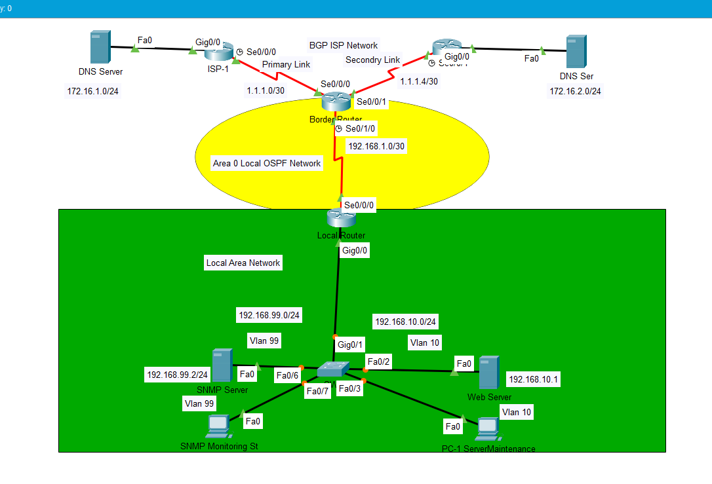

Each device Console Password is cisco

Each device Enable password class

Ssh Username admin

Password cisco

Addressing Table

|  |  |  |  |  |  |
| --- | --- | --- | --- | --- | --- |
| Device | Interface | IP Address | Subnet Mask | Default Gateway | Switch Port |
| ISP1 | S0/0/0 | 1.1.1.1 | 255.255.255.252 |  |  |
| G0/0 | 172.16.1.1 | 255.255.255.0 |  |  |
| ISP2 | S0/0/1 | 1.1.1.5 | 255.255.255.252 |  |  |
| G0/0 | 172.16.2.1 | 255.255.255.0 |  |  |
| Border Router | Loopback0 | 2.2.2.2 | 255.255.255.0 |  |  |
| S0/0/0 | 1.1.1.2 | 255.255.255.252 |  |  |
| S0/0/1 | 1.1.1.6 | 255.255.255.252 |  |  |
| S0/1/0 | 192.168.1.1 | 255.255.255.252 |  |  |
| LocalRouter | Loopback0 | 3.3.3.3 | 255.255.255.0 |  |  |
| S0/0/0 | 192.168.1.2 | 255.255.255.252 |  |  |
| G0/0.10 | 192.168.10.254 | 255.255.255.0 |  | Vlan 10 |
| G0/0.99 | 192.168.99.254 | 255.255.255.0 |  | Vlan 99 |
| SW1 | Vlan99 | 172.168.99.1 | 255.255.255.0 | 192.168.99.254 |  |
| ISP1 Dns Server | NIC | 172.16.1.2 | 255.255.255.0 | 172.16.1.1 |  |
| ISP2 Dns Server | NIC | 172.16.2.2 | 255.255.255.0 | 172.16.2.1 |  |
| Webserver | NIC | 192.168.10.1 | 255.255.255.0 | 192.168.10.254 | Fa0/2 |
| PC1 | NIC | 192.168.10.2 | 255.255.255.0 | 192.168.10.254 | Fa0/3 |
| SNMP M St | NIC | 192.168.99.3 | 255.255.255.0 | 192.168.99.254 | Fa0/7 |
| SNMP Server | NIC | 192.168.99.2 | 255.255.255.0 | 192.168.99.254 | Fa0/6 |

**Configuration**

**Border Router**

Building configuration...

Current configuration : 1889 bytes

!

version 15.1

no service timestamps log datetime msec

no service timestamps debug datetime msec

service password-encryption

!

hostname BorderRouter

enable secret 5 $1$mERr$9cTjUIEqNGurQiFU.ZeCi1

no ip cef

no ipv6 cef

username admin password 7 0822455D0A16

license udi pid CISCO2911/K9 sn FTX1524O05B-

ip ssh version 2

no ip domain-lookup

ip domain-name www.cisco.com

!

!

spanning-tree mode pvst

!

interface Loopback0

ip address 2.2.2.2 255.255.255.0

!

interface GigabitEthernet0/0

no ip address

duplex auto

speed auto

shutdown

!

interface GigabitEthernet0/1

no ip address

duplex auto

speed auto

shutdown

!

interface GigabitEthernet0/2

no ip address

duplex auto

speed auto

shutdown

!

interface Serial0/0/0

ip address 1.1.1.2 255.255.255.252

ip access-group 101 in

no cdp enable

!

interface Serial0/0/1

ip address 1.1.1.6 255.255.255.252

ip access-group 101 in

!

interface Serial0/1/0

ip address 192.168.1.1 255.255.255.252

clock rate 64000

!

interface Serial0/1/1

no ip address

clock rate 2000000

shutdown

!

interface Vlan1

no ip address

shutdown

!

router ospf 1

log-adjacency-changes

redistribute bgp 65001 subnets

network 192.168.1.0 0.0.0.255 area 0

!

router bgp 65001

bgp log-neighbor-changes

no synchronization

neighbor 1.1.1.1 remote-as 65003

neighbor 1.1.1.5 remote-as 65004

network 192.168.1.0 mask 255.255.255.252

redistribute ospf 1

!

ip classless

!

ip flow-export version 9

!

!

access-list 101 permit tcp any host 192.168.10.1 eq www

access-list 101 permit tcp any any

access-list 10 permit host 192.168.99.2

access-list 10 permit host 192.168.99.3

!

line con 0

password 7 0822455D0A16

logging synchronous

login

!

line aux 0

!

line vty 0 4

access-class 10 in

login local

transport input ssh

line vty 5 15

access-class 10 in

login local

transport input ssh

!

!

!

End

**Local Router**

LoRouter#show running-config

Building configuration...

Current configuration : 1687 bytes

!

version 15.1

no service timestamps log datetime msec

no service timestamps debug datetime msec

service password-encryption

!

hostname LoRouter

!

!

!

enable password 7 0822404F1A0A

!

no ip cef

no ipv6 cef

!

username admin password 7 0822455D0A16

!

!

license udi pid CISCO2911/K9 sn FTX15243GBX-

!

ip ssh version 2

no ip domain-lookup

ip domain-name www.cisco.com

!

!

spanning-tree mode pvst

!

interface Loopback0

ip address 3.3.3.3 255.255.255.0

!

interface GigabitEthernet0/0

no ip address

duplex auto

speed auto

!

interface GigabitEthernet0/0.10

encapsulation dot1Q 10

ip address 192.168.10.254 255.255.255.0

!

interface GigabitEthernet0/0.99

encapsulation dot1Q 99

ip address 192.168.99.254 255.255.255.0

!

interface GigabitEthernet0/1

no ip address

duplex auto

speed auto

shutdown

!

interface GigabitEthernet0/2

no ip address

duplex auto

speed auto

shutdown

!

interface Serial0/0/0

ip address 192.168.1.2 255.255.255.252

!

interface Serial0/0/1

no ip address

clock rate 2000000

shutdown

!

interface Vlan1

no ip address

shutdown

!

router ospf 1

log-adjacency-changes

passive-interface GigabitEthernet0/0

network 192.168.1.0 0.0.0.3 area 0

network 192.168.10.0 0.0.0.255 area 0

network 192.168.99.0 0.0.0.255 area 0

!

ip classless

ip route 0.0.0.0 0.0.0.0 Serial0/0/0

!

ip flow-export version 9

!

!

access-list 10 permit host 192.168.99.2

access-list 10 permit host 192.168.99.3

!

line con 0

password 7 0822455D0A16

logging synchronous

login

!

line aux 0

!

line vty 0 4

access-class 10 in

login local

transport input ssh

line vty 5 15

access-class 10 in

login local

transport input ssh

!

!

!

end

**SW1**

SW1#show running-config

Building configuration...

Current configuration : 2058 bytes

!

version 12.2

no service timestamps log datetime msec

no service timestamps debug datetime msec

service password-encryption

!

hostname SW1

!

enable secret 5 $1$mERr$9cTjUIEqNGurQiFU.ZeCi1

!

!

!

ip ssh version 2

no ip domain-lookup

ip domain-name www.cisco.com

!

username admin privilege 1 password 7 0822455D0A16

!

!

!

spanning-tree mode pvst

spanning-tree extend system-id

!

interface FastEthernet0/1

shutdown

!

interface FastEthernet0/2

switchport access vlan 10

switchport mode access

!

interface FastEthernet0/3

switchport access vlan 10

switchport mode access

!

interface FastEthernet0/4

shutdown

!

interface FastEthernet0/5

shutdown

!

interface FastEthernet0/6

switchport access vlan 99

switchport mode access

!

interface FastEthernet0/7

switchport access vlan 99

switchport mode access

!

interface FastEthernet0/8

switchport mode access

shutdown

!

interface FastEthernet0/9

shutdown

!

interface FastEthernet0/10

shutdown

!

interface FastEthernet0/11

shutdown

!

interface FastEthernet0/12

shutdown

!

interface FastEthernet0/13

shutdown

!

interface FastEthernet0/14

shutdown

!

interface FastEthernet0/15

shutdown

!

interface FastEthernet0/16

shutdown

!

interface FastEthernet0/17

shutdown

!

interface FastEthernet0/18

shutdown

!

interface FastEthernet0/19

shutdown

!

interface FastEthernet0/20

shutdown

!

interface FastEthernet0/21

shutdown

!

interface FastEthernet0/22

shutdown

!

interface FastEthernet0/23

shutdown

!

interface FastEthernet0/24

shutdown

!

interface GigabitEthernet0/1

switchport trunk allowed vlan 10,99

switchport mode trunk

!

interface GigabitEthernet0/2

!

interface Vlan1

no ip address

shutdown

!

interface Vlan99

mac-address 0001.c98a.ea01

ip address 192.168.99.1 255.255.255.0

!

ip default-gateway 192.168.99.254

!

!

!

!

access-list 10 permit host 192.168.99.2

access-list 10 permit host 192.168.99.3

line con 0

password 7 0822455D0A16

login

!

line vty 0 4

access-class 10 in

login local

transport input ssh

line vty 5 15

access-class 10 in

login local

transport input ssh

!

end